Lab-4

Student faculty database

**Code:**

create database studentfacdb;

use studentfacdb;

create table STUDENT(

snum int,

sname varchar(60),

major varchar(50),

lvl varchar(50),

age int,

primary key(snum)

);

create table CLASS(

cname varchar(60),

meetsat timestamp,

room varchar(60),

fid int,

primary key (cname)

);

create table enrolled(

snum int,

cname varchar(60),

primary key(snum,cname),

foreign key(snum) references STUDENT(snum)

on update cascade on delete cascade,

foreign key(cname) references CLASS(cname)

on update cascade on delete cascade

);

create table FACULTY(

fid int,

fname varchar(60),

deptid int,

primary key(fid)

);

desc student;

desc class;

desc enrolled;

desc faculty;

insert into STUDENT

values

(1,'Jhon','CS','Sr',19),

( 2,'Smith','CS','Jr',20),

(3,'Jacob','CV','Sr',20),

(4,'Tom','CS','Jr',20),

(5,'Rahul','CS','Jr',20),

(6,'Rita','CS','Sr',21);

insert into CLASS values

('Class1',"12/11/15 10:15:16.00000",'R1',14),

('Class10',"12/11/15 10:15:16.00000",'R128',14),

('Class2',"12/11/15 10:15:20.00000",'R2',12),

('Class3',"12/11/15 10:15:25.00000",'R3',11),

('Class4',"12/11/15 20:15:20.00000",'R4',14),

('Class5',"12/11/15 20:15:20.00000",'R3',15),

('Class6',"12/11/15 13:20:20.00000",'R2',14),

('Class7',"12/11/15 10:10:10.00000",'R3',14);

insert into ENROLLED

values

(1,'Class1'),

(2,'Class1'),

(3,'Class3'),

(4,'Class3'),

(5,'Class4'),

(1,'Class5'),

(2,'Class5'),

(3,'Class5'),

(4,'Class5'),

(5,'Class5');

insert into FACULTY

values

(11,'Harish',1000),

(12,'MV',1000),

(13,'Mira',1001),

(14,'Shiva',1002),

(15,'Nupur',1000);

select * from STUDENT;

select * from CLASS;

select * from ENROLLED;

select * from FACULTY;

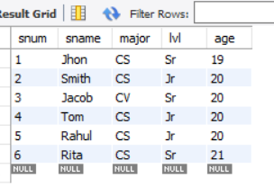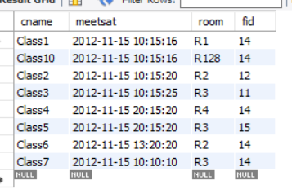

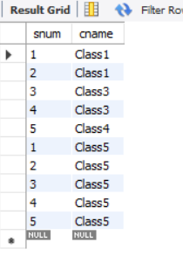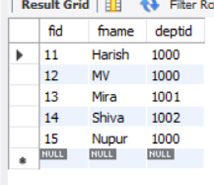

Queries and screenshot:

**1**. select s.sname from STUDENT s, CLASS c, FACULTY f,ENROLLED e

where

s.snum=e.snum and

s.lvl='Jr' and

e.cname=c.cname and

f.fid=c.fid and

f.fname="Harish";

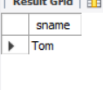

**2.** select c.cname from class c

where c.room = 'R128'or

c.cname in (select e.cname from enrolled e group by e.cname having count(e.snum)>=5);

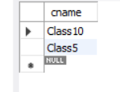

**3**. select distinct s.sname from student s

where

s.snum in

(select e1.snum from enrolled e1, enrolled e2, class c1, class c2

where e1.snum = e2.snum and e1.cname <> e2.cname and e1.cname = c1.cname

and e2.cname = c2.cname and c1.meetsat = c2.meetsat);

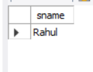

**4.** select distinct f.fname from faculty f

where

not exists

(select room from class

where

room not in (select c.room from class c where c.fid=f.fid));

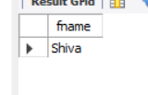

**5.** select distinct f.fname from faculty f

where 5>

(select COUNT(e.snum) from Class c, enrolled e

where c.cname = e.cname and c.fid = f.fid);

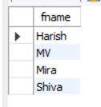

**6.** select distinct s.sname from student s

where

s.snum not in(select e.snum from enrolled e);

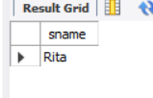

**7.** select S.age,S.lvl,count(*) from student S

group by S.age,S.lvl

having S.lvl in (select s1.lvl from Student s1

where s1.age=S.age

group by s1.age,s1.lvl

having count(*)>=all

(Select count(*) from student s2

where s1.age=s2.age group by s2.lvl,s2.age)

);

